Certificate of Recognition
Contemporary World Studies
United Nations Conference on the Palestinian/Israeli Conflict

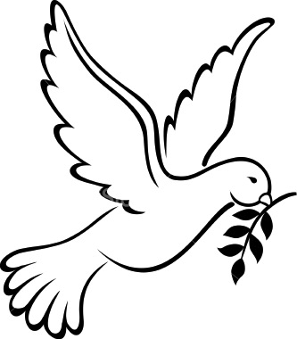
Congratulations

_______________________________________________________________________________________________

on being recognized by your peers for

OUTSTANDING PARTICIPATION DURING THE CONFERENCE

_______________________________________
(teacher’s name)
April 25, 2012

